CHANDERI

The famous Chanderi fabric is a hand-woven combination of silk and cotton. The town of Chanderi, where the craft originated, is still home to master weavers who practice the age-old tradition of creating the cloth on handlooms. Chanderi saris, woven in subtle, pleasant colours, with a rich gold border, are the most popular. The traditional bootis, or motifs, of the saris include lotuses and peacocks. It is said that when this incomparable cloth was first woven, the only colour used was an extraction from the much-prized saffron herb. The delicacy of the weave and the ratio of silk to cotton are the factors that decide the worth of the sari. Nowadays, you can also find scarves, salwar kameez and mens’ jackets made with Chanderi cloth.

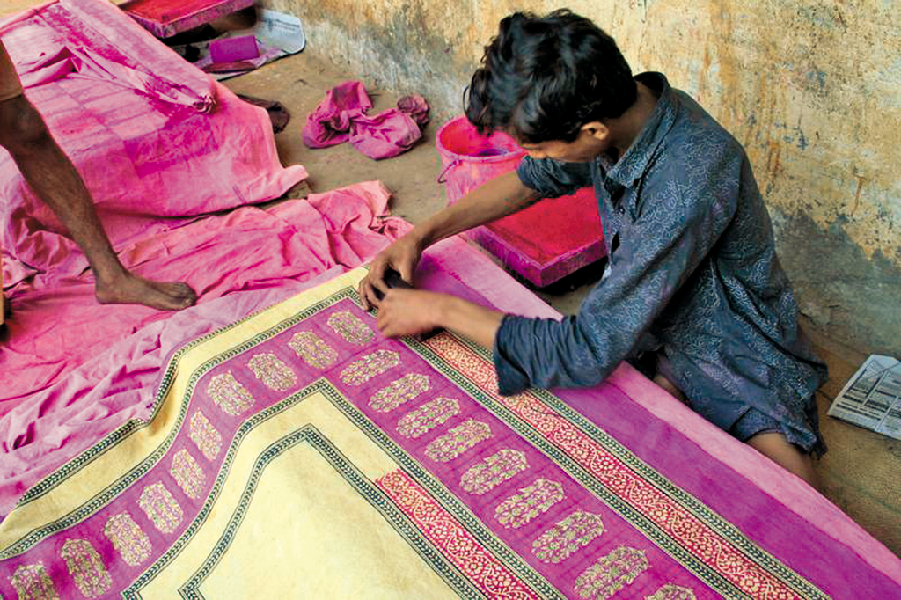

MAHESHWARI

Maheshwari is also a fabric, somewhat similar to Chanderi. It is said to have originated from Maheshwar, a city approximately 90 km from Indore. The fabric was created by weavers, who were brought from Surat by Maharani Ahilya Bai Holkar (1725-1795) to weave cloth for the royal household. The queen, particularly partial to floral designs, and thus the weavers, commanded to only create geometrical motifs, drew inspiration from the detailing of the Maheshwar Fort.

Thus, even today, the main difference between Maheshwari and Chanderi saris is the former’s distinctive design, which comprises checks and stripes, while Chanderi has a less austere touch with pretty floral motifs woven throughout the sari.

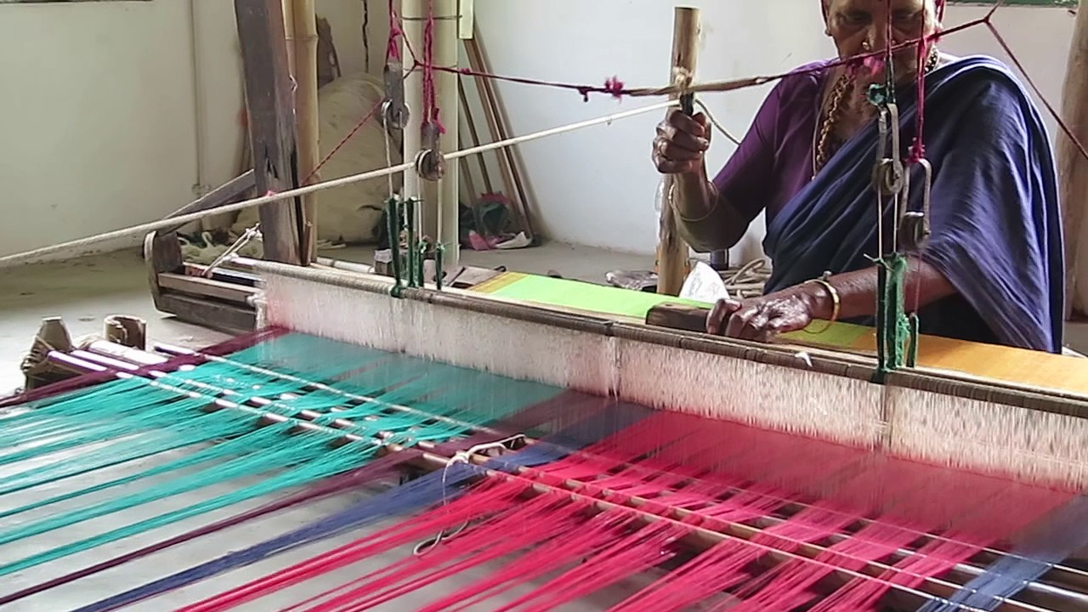

3. BAGH PRINTS, BAGH

The craft as well as the village derive their names from the River ‘Baghini’ that flows through the village and serves as a spine for the craft. Bagh printing is an array of dynamic floral and geometrical prints made using finely cut wooden blocks and vegetable dyes. The characteristic red, black and white used in the motifs are of immense religious and cultural significance in the Dhar tribe of Madhya Pradesh.

The association of tigers (also bagh) with the dense forests surrounding forgotten Buddhist caves near the Bagh river in which the fabric is washed multiple times to achieve a soft texture lends to its name.

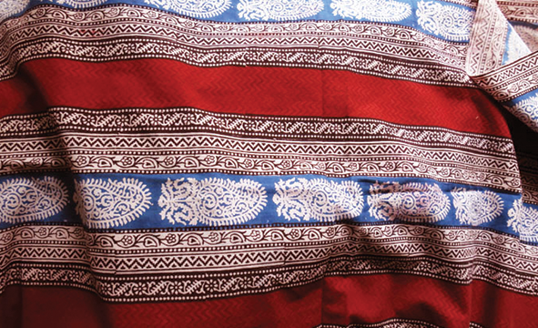

4. ZARI ZARDOZI. BHOPAL

Thriving since the Rig Vedic times, a combination of two urdu words ‘zar’ meaning gold and ‘doz’ meaning hand-work/sewing or embroidery was used to embellish the garments of Royalty. Metallic threads entwining stones and sequins to create elaborate patterns usually for brides. Starting with the Begums of Bhopal, zardozi is now available for export and the rise in popularity has led to an immense appreciation of the traditional artisans dexterity and precision making everyone feel like royalty.

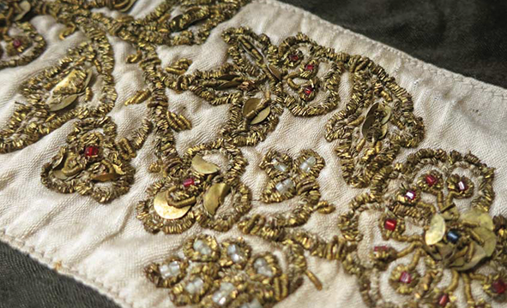

5. BATTO BAI DOLLS, JHABUA

These dolls closely resemble the features of tribes living all across the subcontinent, in a way the tribes identify themselves through this craft. They are gifted to brides and act as meaningful souvenirs and an apt educational tool on the fragile nature of tribes that continue to survive despite all odds against them.

The sustainable process makes use of recycled scrap cloth . The artisans are generally women that undergo 6 months of training and eventually create a doll that grows with you into companionship that is often thrashed onto the floor to prove its sturdy nature.

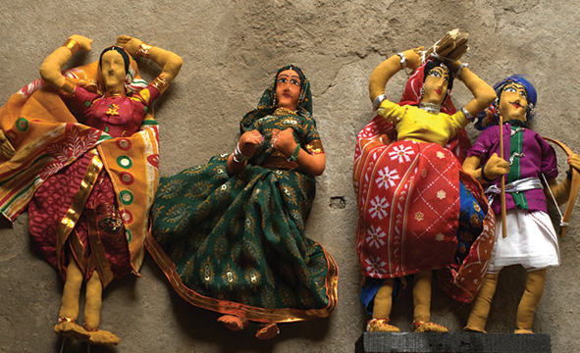

LEATHER ANIMALS, INDORE

Miniature to life size versions of animals from a mere photographic reference is made by craftsmen and their families as they cater to taxidermy enthusiasts. An accurate figurine, complete with posture details and muscular curvature, is skillfully created by the craftsmen with lifelike precision. The leather is stuck and is only worked upon, when orders are placed.Most of the workers involved in the craft belong to the scheduled caste or tribe and often work from home for larger export houses. Women and children are involved in the work too. Different families have specialized themselves in the various steps involved.

